
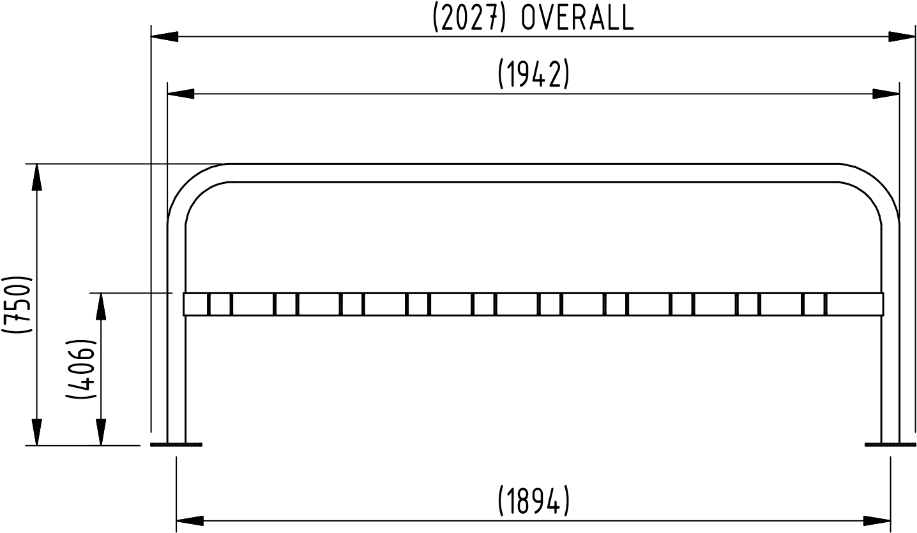
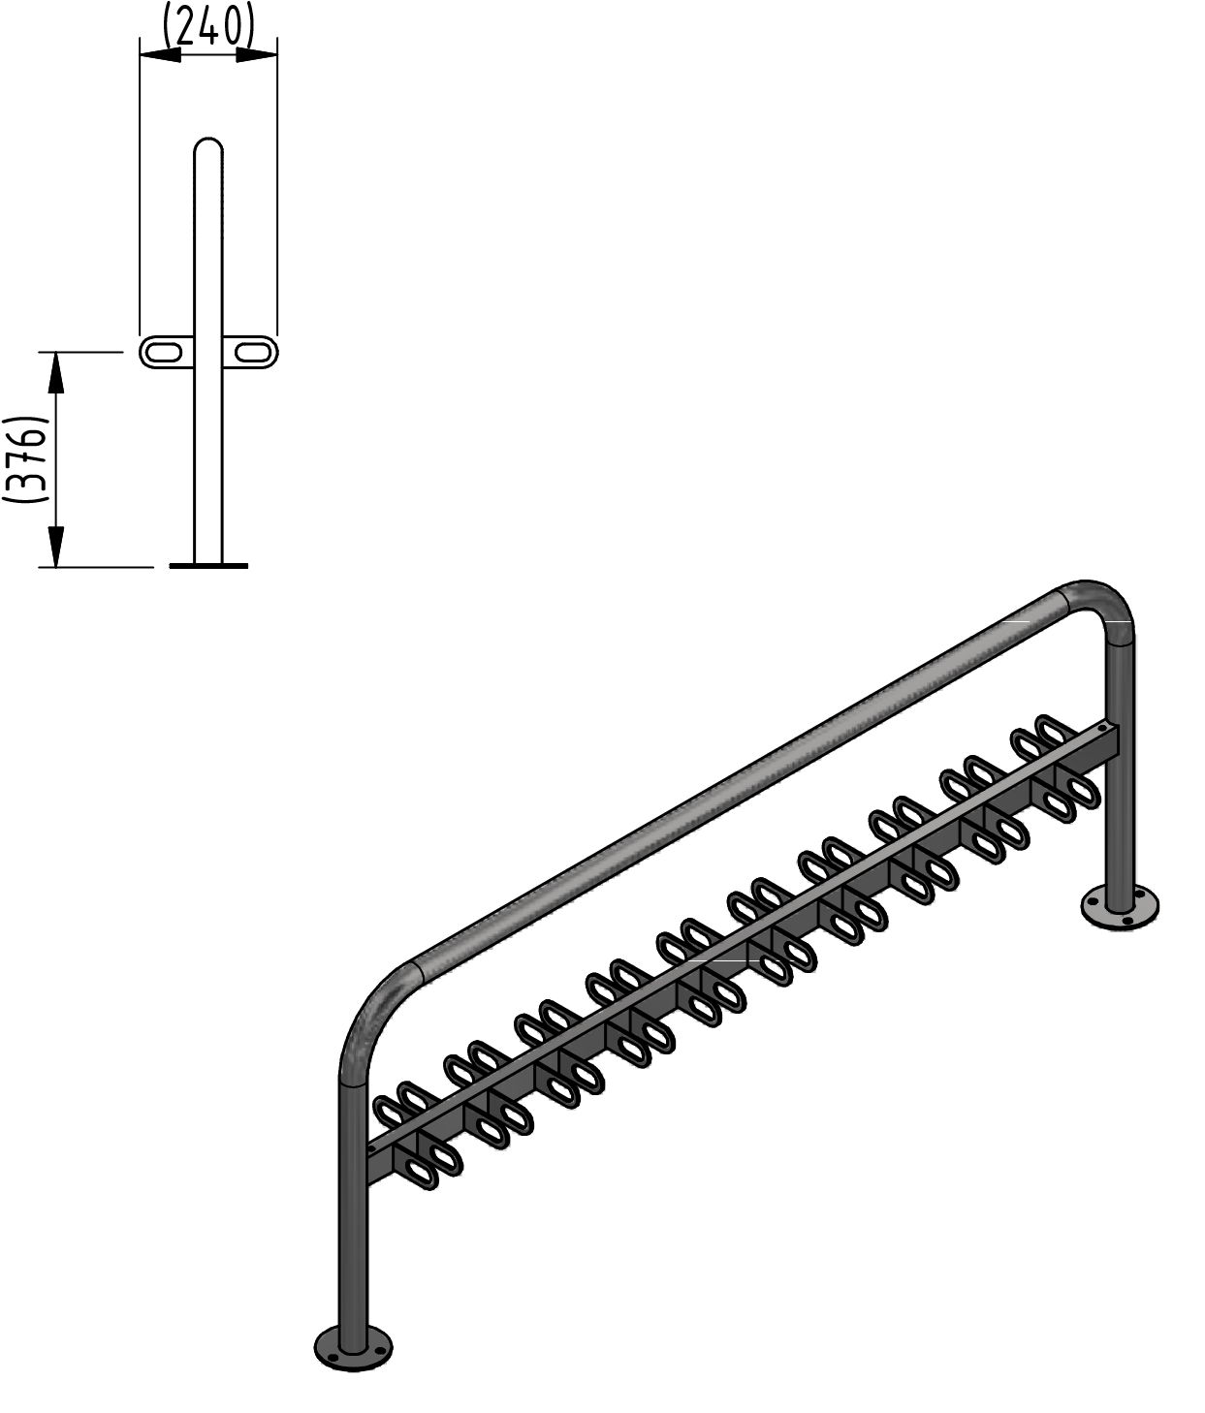
(n14)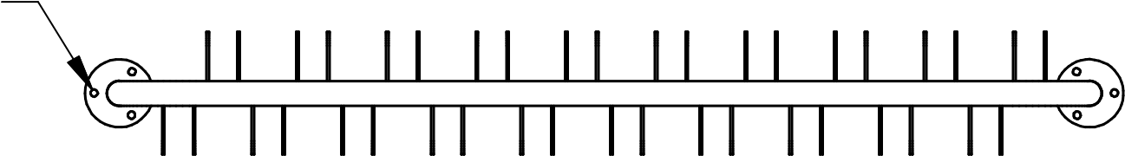
Ø14 HOLES FOR 12mm GROUND FIXINGS
FOUNDATION DETAILS  300mm x 300mm X 300mm CONCRETE AT  EACH LEG POSITION | THE INFORMATION PROVIDED ON THIS DRAWING IS FOR REPRESENTATION PURPOSES ONLY AND SHOULD NOT BE USED FOR MANUFACTURE.  ALL DIMENSIONS ARE IN MILLIMETERS AND ARE TO BE USED FOR REFERENCE ONLY AND SHOULD NOT BE TAKEN AS ACTUALS.  AUTOPA RESERVE THE RIGHT TO CHANGE SPECIFICATIONS WHEN NECESSARY.
TITLE
SCOOTER RACK 20 HOLDER
Part Number: REFERENCE ONLY Printed: 24/08/2023

