The range of Plain Round Bollards offers a simple and cost effective means of establishing control over parking and access. Plain Round Bollards are ideal for use around pedestrian precincts, pavements, play and parking areas, as part of traffic calming measures, pedestrianisation schemes and as a deterrent to ram-raiders.

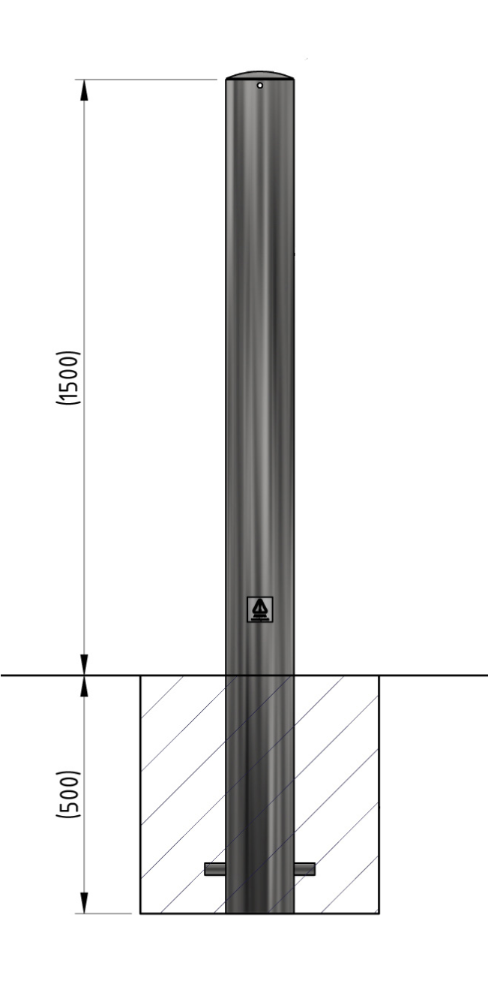

**Plain Round Bollard 1500mm Above Ground**

**114**

**mm - 219mm Diameter**

**Galvanised - Concrete In**

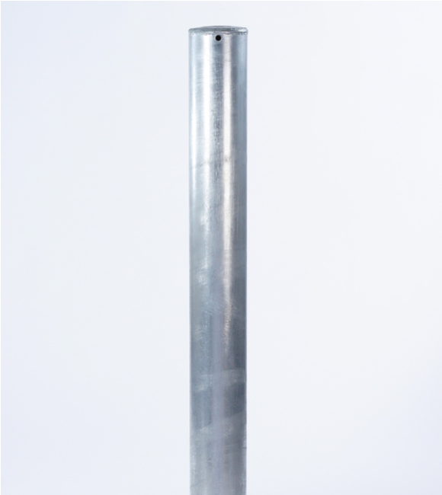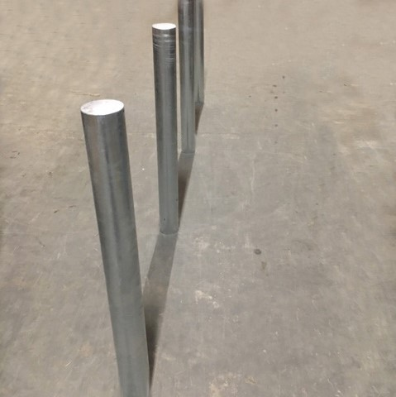

The complete range of Plain Round Bollards is available in diameters from 114mm to 219mm and is available with extended legs for casting into concrete or with a flange plate for bolting down.

Colour coated and removable versions are also available.

|  |  |  |
| --- | --- | --- |
| **Part Number**  **138 121 447**  **138 121 609**  **138 121 680**  **138 121 714**  **138 121 808**  **138 121 908** | **Diameter**  **114mm Galvanised**  **139mm Galvanised**  **152mm Galvanised**  **168mm Galvanised**  **193mm Galvanised**  **219mm Galvanised** | **Weight (kg)**  **16kg**  **33kg**  **22kg**  **40kg**  **47kg**  **53kg** |
| **Product details**   * 3mm wall thickness - 114mm and 152mm * 5mm wall thickness - 139mm, 168mm - 219mm * Concrete in 500mm (below ground) | |  |

**Installation & use**

Bolt down to a suitable concrete surface. Telescopic, removable and concrete in are supplied with welded fixing spikes to ensure firm ground anchorage into concrete. Telescopic, removable and concrete in require a suitable excavated hole for installing into concrete. Products are guaranteed for 12 months (if installed and used correctly).